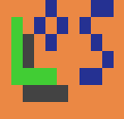

**LongOS User’s Guide**

|  |  |
| --- | --- |
| Author: | Gvin |
| Version: | 1.1 |

# 1 Executive Overview

This guide describes basic user’s features of LongOS product and provides several hints for beginners.

# 2 Table of Content

1 Executive Overview 2

2 Table of Content 3

3 About This Guide 4

4 Basic Interface 5

4.1 Control Panel 5

4.2 Desktop 7

5 Programs and Windows 8

6 Standard Applications 9

6.1 Calculator 9

6.2 BiriPaint 9

6.3 FileManager 11

6.4 Tasks Manager 12

6.5 Terminal 13

7 Customization 14

7.1 Colors customization 14

7.2 Applications customization 15

7.3 Interface customization 16

7.4 Double click speed customization 16

7.5 Desktop wallpaper customization 17

7.6 Adding Programs on Startup 17

8 Conclusion 19

# 3 About This Guide

This guide describes LongOS user’s features and consists of following sections:

* Section 4: Basic Interface

This section provides some basic introduction to the main LongOS interface.

* Section 5: Programs and Windows

This section contains information about basic interface of programs and windows.

* Section 6: Standard applications

This section describes standard build-in applications available for the user.

* Section 7: Customization

This section specifies basic customization mechanisms of the LongOS.

This guide doesn’t requires from reader any deep knowledge of Lua language or ComputerCraft.

# 4 Basic Interface

This section contains the describing of basic LongOS interface, which includes following parts:

* Control Panel
* Desktop

This elements provides some basic functionality and organize working area.

## 4.1 Control Panel

The control panel provides some basic actions and contains time information for the user. It can be seen on picture 4.1.1.

The control panel contains several elements:

* “Applications” button

This button helps user to quickly launch several configured applications.

* “System” button

This button helps user to quickly launch several system applications which can help in using the LongOS.

* “Power” button

Using this button you can quickly shutdown, reboot or even logoff the LongOS with simply two clicks.

* Time display

This area provides information about current Overworld’s time and also gives access to the date menu.



Picture 4.1.1 – The Control Panel

Every of the control panel’s elements is a menu which contains additional actions/information on some topic. To access this menus you should left click any of the elements of the panel. You can see the standard content of the menus on pictures 4.1.2, 4.1.3, 4.1.4 and 4.1.5.

There is also way to change your Control Panel position from top to bottom. See the chapter 7 for more details.

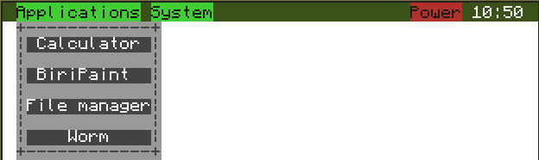

Picture 4.1.2 – The “Applications” menu

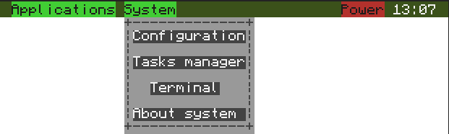

Picture 4.1.3 – The “System” menu

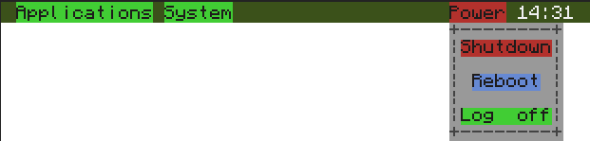

Picture 4.1.4 – The “Power” menu

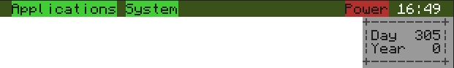

Picture 4.1.5 – The calendar menu

## 4.2 Desktop

The desktop provides pretty background for user’s working area. It is also possible to change the wallpaper on some ready wallpapers or even on your own image. For more information on the wallpapers changing see the section 7. You can see the desktop on picture 4.2.1.

We are planning to add some more functionality to the desktop after some time.

# 5 Programs and Windows

For the purpose of convenience almost all applications contains of windows. There may be several windows in one application working at the same time or not. You can see the standard window on the picture 5.1. Here there are common window’s controls: Close and Maximize/Minimize buttons.

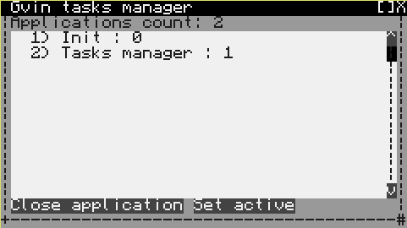

Picture 5.1 – Standard window

The Maximize button doesn’t always present on the window. It may be missing if the window is not allowed to be maximized. You can configure this buttons to be displayed on the left side of the window. For more information about this see the section 7.

In the left bottom corner you can see the ‘#’ symbol. It shows that it is possible to resize the window by simple dragging this corner by your mouse while holding the left mouse button.

It is also possible to move windows. To do this you just need to drag the window on its top line by your mouse while holding the left mouse button.

There are several limitations of the window size and position. Also some windows cannot be moved or resized. This options are specified by programmers in their programs.

It is also possible to customize window’s colors in wide diapason. More information about this you can find in the section 7.

# 6 Standard Applications

In the LongOS there are several standard applications available for users right after the installation. The list of this programs is:

* Calculator
* BiriPaint
* FileManager
* Tasks Manager
* Terminal

This programs can help user to work with his/her files, pictures and programs.

## 6.1 Calculator

Calculator is the standard calculating program. It is only capable of simple calculations. See picture 6.1.1.

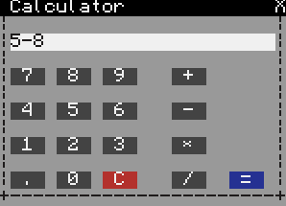

Picture 6.1.1 – The Calculator window

## 6.2 BiriPaint

BiriPaint is an advanced program for painting. With it you can create images for using them as a wallpaper or in your programs. You can use a lot of tools to create interesting pictures even quicker than earlier. It is also possible to specify image size if you are going to use this images with computers with higher resolution. See pictures 6.2.1 and 6.2.2.

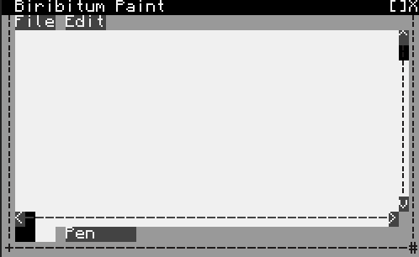

Picture 6.2.1 – BiriPaint main window

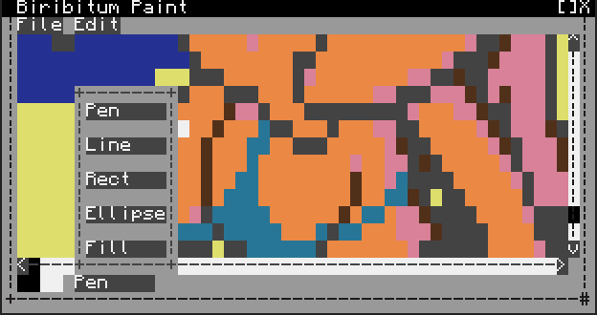

Picture 6.2.2 – BiriPaint tools

## 6.3 FileManager

FileManager is an advanced program for working with your files. You can do everything you could do in CraftOS and even more. It is possible to inspect, create, remove, cut and copy your files and folders. See picture 6.3.1.

FileManager is also capable of interacting with some standard programs. If you will double-click some “.exec” files (executable), the application will be launched. And if you will double-click the “.image” file (created by BiriPaint) the BiriPaint with this image loaded will be opened.

You can also launch your old terminal programs from here using the “Run in terminal” option from the popup menu. This action will launch the terminal emulator program (see section 6.5) with your selected program file. You can also double-click file with “.lua” extension to launch it in the terminal emulator. From LongOS v1.1 you can also launch editing program for selected file using the popup menu. See picture 6.3.2.

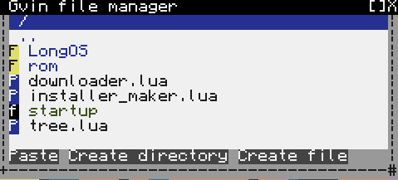

Picture 6.3.1 – FileManager window

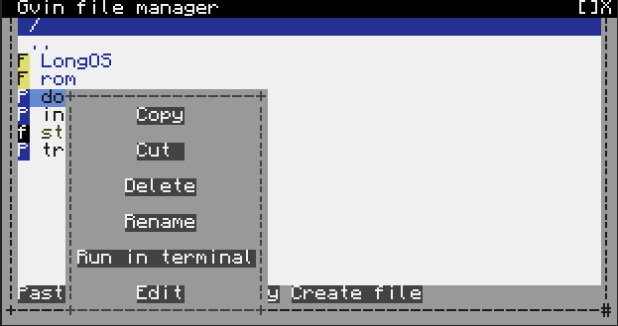

Picture 6.3.2 – FileManager’s popup menu

## 6.4 Tasks Manager

Tasks Manager is the standard programs for managing your launched application and easy switching from one to another. It is also capable of “killing” an application if it’s required. See picture 6.4.1.

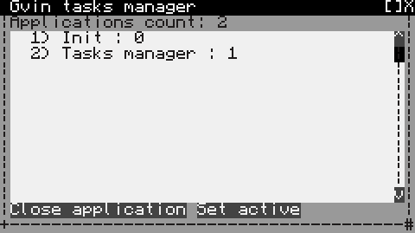

Picture 6.4.1 – Tasks Manager window

## 6.5 Terminal

The Terminal program provides you with emulation of the standard CraftOS terminal and gives the ability to launch old-style applications in windows. This also includes multitasking and background processing data while playing some games for example. See picture 6.5.1. You can launch Terminal in two ways:

* By launching “Terminal” program from the “System” menu.
* By selecting “Run in terminal” option in the FileManager.

If the application was called by the second way it will close after the program ands.

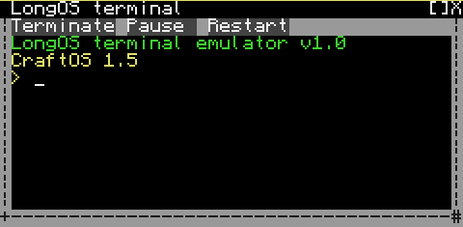

Picture 6.5.1 – Terminal window

# 7 Customization

In LongOS there are a lot of parameters to customize. The list of customizable options are:

* Colors
* Applications in the “Applications” menu
* Control panel and mouse buttons position
* Double click speed
* Desktop wallpaper
* Adding programs on startup

Almost all this parameters can be customized by using the standard application — the ConfigurationManager. See picture 7.1. From this manager you can select some part to customize.

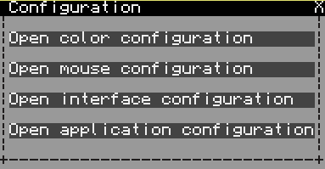

Picture 7.0.1 – ConfigurationManager window

## 7.1 Colors customization

You can customize your system’s colors in color configuration window (picture 7.1.1). Here you can see the list of available configurations and can select colors for this configurations. To change color simply select the configuration from the list box in the left and the click on che colored panel in the right. The color selection window will appear where you can set new color for this option.

To save changes you have made in the configuration simply press the “Save changes” button.

If you click “Set default” button color configuration will be reseted to default.

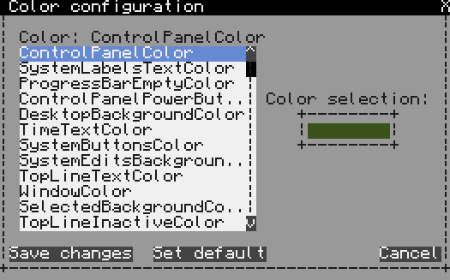

Picture 7.1.1 – Color configuration window

## 7.2 Applications customization

It is possible to customize the list of applications you see in the “Applications” menu on the Control Panel. To do this you should open the Application configuration window (picture 7.2.1). Here you can add, remove, edit and rearrange this programs.

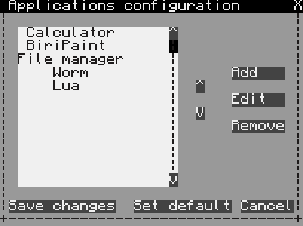

Picture 7.2.1 – Application configuration window

## 7.3 Interface customization

It is possible to customize several interface options such as control panel and window buttons position. You can do this in the interface configuration window (picture 7.3.1).

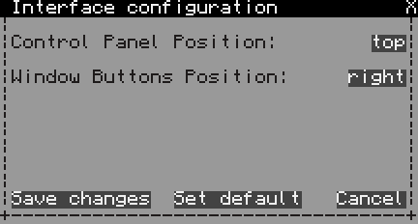

Picture 7.3.1 – Interface configuration window

## 7.4 Double click speed customization

It is possible to customize double click speed. You can do this in the mouse configuration window (picture 7.4.1). Here you can see a text box for entering interval for waiting another click after a single click. The bigger value you select, the slower your double-clicks can be.

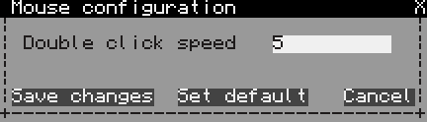

Picture 7.4.1 – Mouse configuration window

## 7.5 Desktop wallpaper customization

It is possible to change desktop wallpaper on some of the default wallpapers or even on your own image. Only image which was created with BiriPaint can be used as a wallpaper.

To do this you should right-click the desktop and select “Change wallpaper” option from the popup menu (picture 7.5.1). This will open the Wallpaper manager program where you can see current wallpaper path and set your own path (picture 7.5.2). On this window you can also enter image shifting from top left corner of the screen for large size images. This values can also be negative.

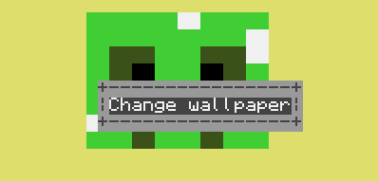

Picture 7.5.1 – Desktop popup menu

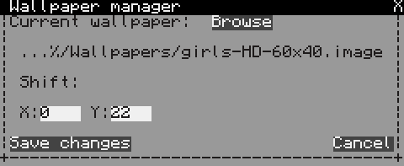

Picture 7.5.2 – Wallpaper manager window

## 7.6 Adding Programs on Startup

LongOS is capable of starting some programs on the system’s startup. This allows you to create servers or other programs which must be started on turning the computer on.

To add a program on startup you simply should add its path as a new line to the file “autoexec” which is located at “/LongOS/Configuration/autoexec”.

The sample for standard LongOS program is:

/LongOS/Utilities/FileManager/GvinFileManager.exec

To add a terminal program on startup you should first write the path to the GvinTerminal program and then path to your program:

/LongOS/SystemUtilities/Terminal/GvinTerminal.exec worm

You can add several programs on startup by adding multiple lines to this file.

# 8 Conclusion

LongOS was created to make every day’s actions faster and easier for different users. This is the main purpose of our project. A lot of work was done since the beginning and a lot of work is still to be done. If you have any suggestions or have found any bugs please use [GitHub issues](https://github.com/Gvin/LongOS/issues) to report about that.